# Sandstorm Retro Low-tops

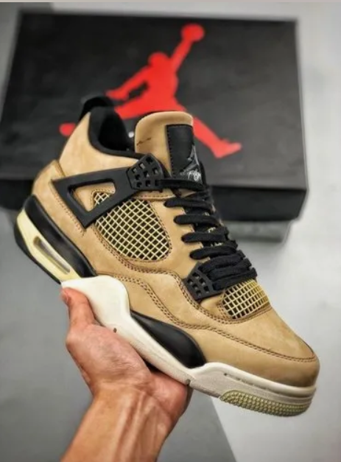

Product Details:

Color Combination: The Jordan Sandstorm Retro Low-tops showcase a unique and earthy color palette including #ceab77 (sandy beige), #f1ebd7 (creamy white), and #383b38 (deep olive green).

Material: Crafted from premium synthetic leather and breathable textile materials, ensuring durability, comfort, and style.

Sole: Features a responsive and cushioned sole unit with a contrasting olive green accent, providing optimal support and comfort during wear.

Closure: Secure lace-up closure system for a customizable and snug fit.

Branding: Signature Jumpman logo detailing prominently displayed on the tongue and heel, showcasing the shoe's authentic Jordan heritage.

Comfort: Padded collar and cushioned insole offer exceptional comfort, making them perfect for all-day wear.

Style: The Jordan Sandstorm Retro Low-tops exude a sense of casual elegance, making them suitable for various occasions from casual outings to streetwear-inspired looks.

Occasion: Ideal for everyday wear, urban adventures, or adding a touch of athletic style to your ensemble.

Versatility: Pair with jeans, joggers, or even casual shorts for a versatile and fashion-forward look that showcases your love for the iconic Jordan brand.